Crack Visual Micro quickly

1. Studio\2019\Community\Common7\IDE\Extensions\4mjgbabg.jbr\Visual.Micro.Processing.Sketch.dll"
2. Replace Visual.Micro.Processing.Sketch.dllBackup "C:\Program Files (x86)\Microsoft Visual

Crack Visual Micro manually

<https://cxymm.net/article/qq_29355641/120098202>

1. Run Visual Studio 2019 Developer Command Prompt
2. Make sure you have installed Packet SDK .Net Framework 4.8 for ildasm.
3. Run ildasm "C:\Program Files (x86)\Microsoft Visual Studio\2019\Community\Common7\IDE\Extensions\4mjgbabg.jbr\Visual.Micro.Processing.Sketch.dll" /out=C:\Users\Denis\Desktop\dll\Visual.Micro.Processing.Sketch.il
4. Find “ProductActivated” in C:\Users\Denis\Desktop\dll\Visual.Micro.Processing.Sketch.il
5. Replace IL code in Visual.Micro.Processing.Sketch.il and save:

.maxstack 1

.locals init (int32 V_0,

bool V_1,

bool V_2,

bool V_3)

IL_0000: nop

IL_0001: ldc.i4.1

IL_0002: stloc.0

IL_0003: br.s IL_0005

IL_0005: ldloc.0

IL_0006: ret

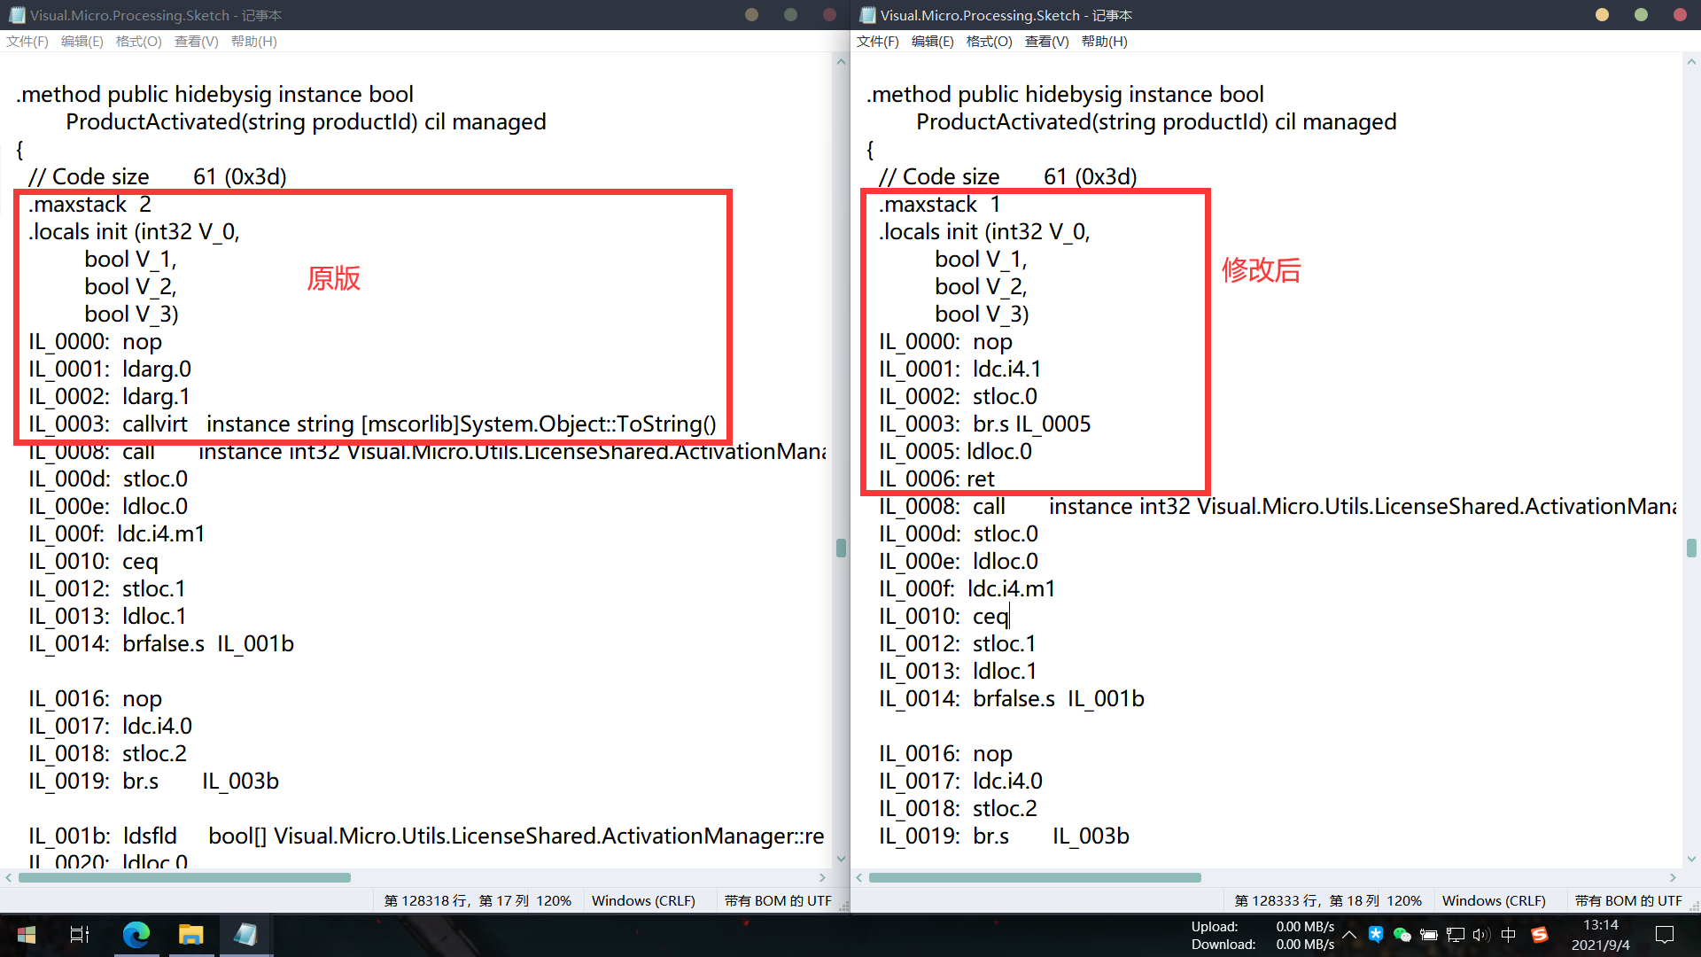

1. Run c:\windows\microsoft.net\framework\v4.0.30319\ilasm.exe /dll/resource=C:\Users\Denis\Desktop\dll\Visual.Micro.Processing.Sketch.res C:\Users\Denis\Desktop\dll\Visual.Micro.Processing.Sketch.il
2. Backup and replace new C:\Users\Denis\Desktop\dll\Visual.Micro.Processing.Sketch.dll in C:\Program Files (x86)\Microsoft Visual Studio\2019\Community\Common7\IDE\Extensions\4mjgbabg.jbr\